PROJECT-45
AI SEO Optimizer
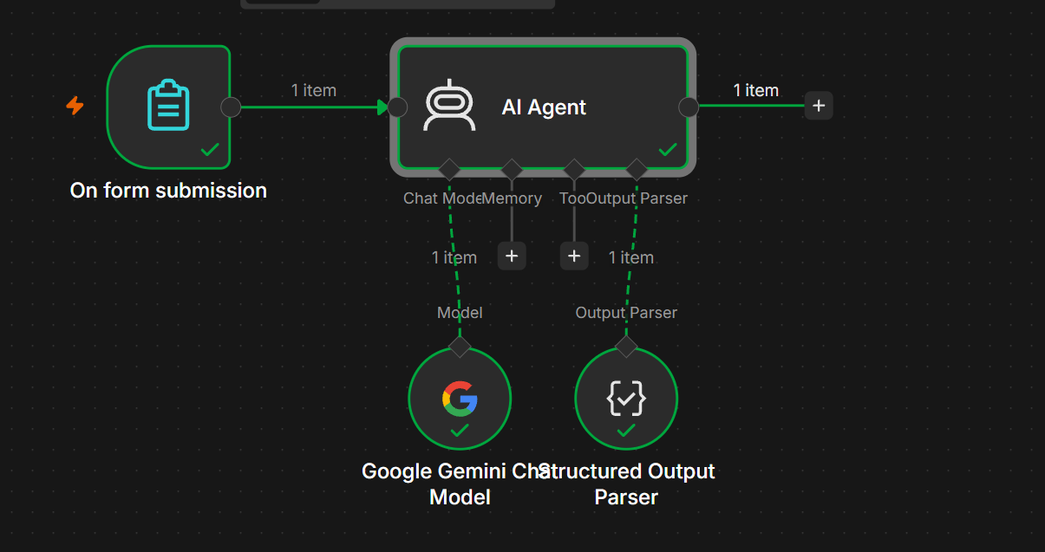
AI SEO Optimizer — n8n Documentation
Yes — you can build AI SEO Optimizer using the same pattern you've been using for your other projects:
On Form Submission
↓
AI Agent
↙ ↘
Gemini Output Parser
↓
SEO JSON Output
You do not need a Vector Store for the basic version.

1. What the AI SEO Optimizer Does
The user enters:
- Website/page title
- Existing content
- Target keyword
- Secondary keywords
- Target audience
The AI analyzes the content and generates:
- SEO title
- Meta description
- Primary keyword
- Secondary keywords
- Suggested URL slug
- Improved headings
- SEO recommendations
- Optimized content
- Internal linking suggestions
- Image/alt-text suggestions
- SEO score

2. Workflow Nodes
Add these nodes:
- On Form Submission
- AI Agent
- Google Gemini Chat Model
- Structured Output Parser
Your workflow:
On Form Submission
↓
AI Agent
↓
Structured Output Parser
And:
Google Gemini Chat Model
↓
AI Agent

3. Step 1 — On Form Submission
Add:
On Form Submission
Create these fields.
Field 1 — Page Title
Type:
Text
Page Title
Example:
Best Digital Marketing Strategies

Field 2 — Target Keyword
Type:
Text
Target Keyword
Example:
digital marketing strategies

Field 3 — Secondary Keywords
Type:
Text
Secondary Keywords
Example:
SEO, social media marketing, content marketing, online advertising

Field 4 — Target Audience
Type:
Text
Target Audience
Example:
Small business owners

Field 5 — Existing Content
Type:
Text Area
Existing Content
This is the most important field.
The user pastes their existing webpage/article content here.

4. Example Form
Your form will look like:
Page Title:
Best Digital Marketing Strategies

Target Keyword:
digital marketing strategies

Secondary Keywords:
SEO, social media marketing, content marketing, online advertising

Target Audience:
Small business owners

Existing Content:
Digital marketing has become important for businesses...

5. Step 2 — AI Agent
Connect:
On Form Submission
↓
AI Agent
Open the AI Agent.
For Prompt (User Message) choose:
Define below
Use:
Analyze and optimize the following webpage content for SEO.

Page Title:
{{ $json['Page Title'] }}

Target Keyword:
{{ $json['Target Keyword'] }}

Secondary Keywords:
{{ $json['Secondary Keywords'] }}

Target Audience:
{{ $json['Target Audience'] }}

Existing Content:
{{ $json['Existing Content'] }}

Perform a complete SEO analysis.

Analyze:
1. Current content quality
2. Keyword usage
3. Search intent
4. Title optimization
5. Meta description
6. Heading structure
7. Content readability
8. Keyword opportunities
9. Internal linking opportunities
10. Image/alt-text opportunities

Then provide an optimized SEO version and actionable recommendations.

6. Step 3 — System Message
Use:
You are an AI SEO Optimization Specialist.

Your job is to analyze webpage content and provide practical SEO improvements.

IMPORTANT RULES:

1. Analyze the provided content carefully.
2. Use the provided target keyword as the primary keyword.
3. Use secondary keywords naturally.
4. Do not keyword-stuff the content.
5. Keep the content natural and readable.
6. Do not invent facts that are not supported by the provided content.
7. Optimize the title for search engines and users.
8. Create a concise and relevant meta description.
9. Suggest a clean SEO-friendly URL slug.
10. Analyze heading structure.
11. Identify content gaps.
12. Suggest internal linking opportunities.
13. Suggest relevant image alt text.
14. Consider search intent.
15. Provide actionable recommendations.
16. Give an SEO score from 0 to 100.
17. Return the result using the required structured output format.

7. Step 4 — Google Gemini Chat Model
Add:
Google Gemini Chat Model
Connect it to the Chat Model input of the AI Agent.
Google Gemini Chat Model
↓
Chat Model
↓
AI Agent
Don't connect Gemini using the normal green workflow line.

8. Step 5 — Structured Output Parser
Add:
Structured Output Parser
Connect it to:
AI Agent
↓
Output Parser
Then use Generate from JSON Example.
Paste:
{
"seo_score": 78,
"primary_keyword": "digital marketing strategies",
"secondary_keywords": [
"SEO",
"social media marketing",
"content marketing"
],
"optimized_title": "10 Effective Digital Marketing Strategies for Small Businesses",
"meta_description": "Discover effective digital marketing strategies that help small businesses improve online visibility, attract customers, and grow their business.",
"url_slug": "digital-marketing-strategies-small-business",
"search_intent": "Informational",
"content_summary": "The article explains digital marketing strategies that small businesses can use to improve their online presence.",
"heading_suggestions": [
"What Are Digital Marketing Strategies?",
"10 Digital Marketing Strategies for Small Businesses",
"How to Choose the Right Digital Marketing Strategy"
],
"keyword_recommendations": [
"online marketing",
"digital marketing for small business",
"online advertising"
],
"content_gaps": [
"Add practical examples",
"Include recent statistics",
"Add a section explaining how to measure results"
],
"internal_link_suggestions": [
"Link to the SEO services page",
"Link to the content marketing guide"
],
"image_alt_text_suggestions": [
"Small business digital marketing strategy",
"Digital marketing analytics dashboard"
],
"readability": "Good",
"recommendations": [
"Improve the introduction",
"Add keyword variations naturally",
"Use more descriptive headings",
"Add internal links"
]
}

9. Final Workflow
Your canvas should look like this:
┌──────────────────────────────┐
│ On Form Submission │
│ │
│ Page Title │
│ Target Keyword │
│ Secondary Keywords │
│ Target Audience │
│ Existing Content │
└──────────────┬───────────────┘
│
▼
┌─────────────┐
│ AI Agent │
└──────┬──────┘
│
▼
Structured Output Parser
And:
Google Gemini Chat Model
│
▼
AI Agent

10. Test It
Use this information in your form.
Page Title
Digital Marketing Tips
Target Keyword
digital marketing strategies
Secondary Keywords
SEO, social media marketing, content marketing
Target Audience
Small business owners
Existing Content
Digital marketing is important for businesses that want to
reach customers online. Businesses can use social media,
SEO and content marketing to promote their products and
services.

SEO helps businesses appear in search engines. Social media
allows businesses to communicate with customers. Content
marketing helps businesses provide useful information to
their audience.

11. Expected Output
You should get something similar to:
{
"seo_score": 78,
"primary_keyword": "digital marketing strategies",
"optimized_title": "10 Effective Digital Marketing Strategies for Small Businesses",
"meta_description": "Discover effective digital marketing strategies that help small businesses improve online visibility, attract customers, and grow their business.",
"url_slug": "digital-marketing-strategies-small-business",
"search_intent": "Informational",
"readability": "Good",
"content_gaps": [
"Add practical examples",
"Add measurement strategies"
],
"recommendations": [
"Improve the introduction",
"Use keyword variations naturally",
"Add descriptive headings",
"Add internal links"
]
}

12. SEO Score
Use a score from 0–100.
Example:
Score | Meaning
0–30 | Poor
31–50 | Needs significant improvement
51–70 | Average
71–85 | Good
86–100 | Excellent
The score should be based on factors such as:
- Keyword relevance
- Search intent
- Title
- Meta description
- Heading structure
- Content quality
- Readability
- Content depth
- Internal linking opportunities

13. Example SEO Analysis
Input
Target Keyword:
best laptops for students
The AI might return:
SEO Score: 72

Optimized Title:
10 Best Laptops for Students in 2026

Meta Description:
Discover the best laptops for students, including affordable,
powerful and lightweight options for study, coding and everyday use.

URL:
best-laptops-for-students

Search Intent:
Commercial Investigation

14. What You Learn From This Project
This project teaches:
- n8n Form Trigger
- AI Agent
- Google Gemini
- Prompt Engineering
- Dynamic expressions
- Structured Output Parser
- SEO analysis
- Keyword analysis
- Content optimization
- Search intent analysis
- JSON output

15. Important Difference From Your Other Projects
For your AI HR Assistant, you needed:
Vector Store
↓
Embeddings
↓
RAG
For your AI Expense Categorizer, you needed:
Form
↓
AI Agent
↓
Structured Output
For AI SEO Optimizer, use:
Form
↓
AI Agent
↓
Gemini
↓
Structured Output
No Vector Store is required for the basic version.

16. Optional Advanced Version
Later you can add:
Form
↓
AI SEO Optimizer
↓
SEO Score
↓
IF
├── Score < 70
│ ↓
│ Generate Improvements
│
└── Score >= 70
↓
Approve
You can also add Google Sheets to store:
URL
Keyword
SEO Score
Title
Meta Description
Recommendations
Date
That turns this into a complete SEO auditing and optimization automation.

